|  |  |
| --- | --- |
|  | FPT ACADEMY INTERNATIONAL  FPT – APTECH COMPUTER EDUCATION |

Centre Name: ACE-HCMC-2-FPT.

Address: 590 Cach Mang Thang 8, District 3, Ho Chi Minh City, Viet Nam.

**[Bright World]**

|  |  |  |
| --- | --- | --- |
| Supervisor: | Phạm Thị Lánh | |
| Term: | T1.2112.E0 | |
| Batch No: | 1 | |
| Group No: | 1 | |
| Order: | Full name | Roll No. |
| 1. | Vũ Đông Nam | Student1352239 |
| 2. | Nguyễn Minh Sơn | Student1352243 |
| 3. | Khưu Nguyễn Lan Anh | Student1352176 |

Month 04 Year 2022

This is to certify that

**Mr. VŨ ĐÔNG NAM**

**Mr. NGUYỄN MINH SƠN**

**Ms. KHƯU NGUYỄN LAN ANH**

Have successfully Designed & Developed

**BRIGHTWORLD**

Submitted by: **Ms. PHAM THI LANH**

Date Of Issue:

Authorized Signature:

# Content

Content 3

Acknowledge 5

Synopsis 6

Review 1 7

Problem Definition 7

Customer Requirements Specifications 9

Architecture and Design of the project 11

Site map 12

Screen shots 14

I. Homepage 14

II. Sign in 16

III. Sign up 17

IV. Sales 18

V. Product Category/Search Page 20

VI. Product Comparison 21

VII. Product Detail 22

VIII. Cart Dropdown 25

IX. Check out 26

X. Contact 28

XI. About 30

Task Sheet 32

Review 2 33

I. Homepage 33

II. Sign in 35

III. Sign up 36

IV. Sales 36

V. Product Category/Search Page 38

VI. Product Comparison 39

VII. Product Detail 40

VIII. Cart Dropdown 41

IX. Check out 42

X. Contact 43

XI. About 44

Task Sheet 46

Testing document 47

Final checklist 48

# Acknowledge

As we understand that the eProject is a step-by-step learning environment that closely simulates the classroom and Lab based learning environment into actual implementation. It is a project implementation at your fingertips!! An electronic, live juncture on the machine that allows you to.

✓ Practice step by step i.e., laddered approach.

✓ Build a larger, more robust application.

✓ Usage of certain utilities in applications designed by the user.

✓ Single program to unified code leading to a complete application.

✓ Learn implementation of concepts in a phased manner.

✓ Enhance skills and add value.

✓ Work on real life projects.

✓ Give a real-life scenario and help to create applications more complicated and useful.

✓ Mentoring through email support.

We would like to send a great thank to our professor and others student for the adorable support during the time in the project.

Beside several mistakes we had made in the project, we hope to have more opportunities to widen our knowledge in the web developing world.

We also thank you so much for your information and the “demo” project from India APTECH to help us get more reality experience in this project. Since we have gained more experience from this project, we will not stop learning anything as much as we can to be more successful in the future.

Your Sincerely,

Team Group 01.

# Synopsis

- The Objective of this program we aim is to give a sample project to work on real life projects. These applications help us build a larger, more robust application.

- The objective is not to teach us HTML/JavaScript but to provide us with a real life scenario and help us create basic applications using the tools.

- Hence, we can revise the chapters before we start with the project.

- This project The Objective of this program is to give a sample project to work on real life projects. These applications help you build a larger, more robust application.

- The objective is not to teach you the software but to provide you with a real-life scenario and help you create basic applications using the tools.

- You can revise the topics before you start with the project.

- This project is meant for students who have completed the module of HTML5.

- These programs should be done in the Lab sessions with assistance of the faculty if required.

- The website (in this project) is a tool that help the company to access the

international market and gain more and more new customers.

- It is very essential that a student has a clear understanding of the subject.

|  |  |  |
| --- | --- | --- |
| **Design plan:** Bright World Limited | **Document name:** Problem Definition | **SWD/Form:** No.05/PD/Ver1.0 |
| **Effective date:** | **Version:** 1.0 | **Page No:** 1 of 1 |

# Review 1

## Problem Definition

BrightWorld has a store for LED Lights. They have a collection of lights. Now with the changing environment, they want their presence on the Internet. Hence they need to have a website with all their products listed on the website. Consumers should find it easy to view various products and decide upon purchasing the right product to meet their requirements.

A website needs to be designed to display various lights available with the store. Details of locations using GeoLocation API (eg. GoogleMaps), feedback must be included.

The website is to be developed for the Windows Platform using HTML5, JavaScript and Geolocation. The site should work well in all leading browsers including Chrome, IE, Firefox etc.

Here are some problems need to be resolved:

1. With the changing environment, more and more customers are interested in shopping online and this issue leads to the situation that customers want to find information about various products easily on the Bright World website and purchase the right product that meets their needs.

2. The product range is not known to quite a few customers; they just order on the basis of the feedback or recommendations given by their friends or colleagues and after delivery of the product it does not match either the requirements or expectations leading to wastage of time, resources and delivery costs.

3. Online customers have an interest in reading reviews before purchasing specific products.

4. Existing customers needing some help and support on the product after installation would have to contact the Bright World office through phone number or email address. Moreover, many customers want to come to the store to view the product and then decide whether to buy it or not.

|  |  |  |
| --- | --- | --- |
|  | Prepared by (Student) | Approved by (Faculty) |
|  | Project Group No: 01 | PHAM THI LANH |
| Signature |  |  |
| Date |  |  |

|  |  |  |
| --- | --- | --- |
| **Design plan:** Bright World Limited | **Document name:** Customer Requirements Specifications | **SWD/Form:** No.05/CRS/Ver1.0 |
| **Effective date:** | **Version:** 1.0 | **Page No:** 1 of 2 |

## Customer Requirements Specifications

|  |
| --- |
| USER: |
| Input:  ● Input consumer’s address of residence or office  ● Send questions/requests to the company |
| Process:  ● Process consumer’s address data  ● Collect questions/requests sent by consumers |
| Output:  ● Show the store address to consumers  ● Reply to the consumer’s requests/questions |

|  |
| --- |
| WEBMASTER: |
| Input:  ● Control website database, input product information,… |
| Process:  ● Analyse website |
| Output:  ● Website interface, images, forms, …  ● Giving interaction |

|  |  |  |
| --- | --- | --- |
|  | Prepared by (Student) | Approved by (Faculty) |
|  | Project Group No: 01 | PHAM THI LANH |
| Signature |  |  |
| Date |  |  |

|  |  |  |
| --- | --- | --- |
| **Design plan:** Bright World Limited | **Document name:** Customer Requirements Specifications | **SWD/Form:** No.05/CRS/Ver1.0 |
| **Effective date:** | **Version:** 1.0 | **Page No:** 2 of 2 |

|  |
| --- |
| HARDWARE / SOFTWARE REQUIREMENT: |
| Software:  ● Notepad/HTML editor  ● Dreamweaver/Javascript |
| Hardware:  ● A minimum computer system that will help you access all the tools in the courses is a Pentium 166 or better  ● 64 Megabytes of RAM or better |

|  |  |  |
| --- | --- | --- |
|  | Prepared by (Student) | Approved by (Faculty) |
|  | Project Group No: 01 | PHAM THI LANH |
| Signature |  |  |
| Date |  |  |

|  |  |  |
| --- | --- | --- |
| **Design plan:** Bright World Limited | **Document name:** Architecture and Design of the project | **SWD/Form:** No.05/ARD/Ver1.0 |
| **Effective date:** | **Version:** 1.0 | **Page No:** 1 of 1 |

## Architecture and Design of the project



|  |  |  |
| --- | --- | --- |
|  | Prepared by (Student) | Approved by (Faculty) |
|  | Project Group No: 01 | PHAM THI LANH |
| Signature |  |  |
| Date |  |  |

|  |  |  |
| --- | --- | --- |
| **Design plan:** Bright World Limited | **Document name:** Site map | **SWD/Form:** No.05/SM/Ver1.0 |
| **Effective date:** | **Version:** 1.0 | **Page No:** 1 of 1 |

## Site map

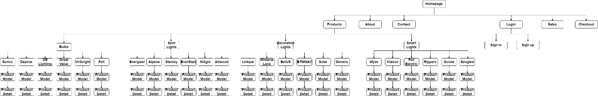

|  |  |  |
| --- | --- | --- |
|  | Prepared by (Student) | Approved by (Faculty) |
|  | Project Group No: 01 | PHAM THI LANH |
| Signature |  |  |
| Date |  |  |

|  |  |  |
| --- | --- | --- |
| **Design plan:** Bright World Limited | **Document name:** Screen shots | **SWD/Form:** No.05/SS/Ver1.0 |
| **Effective date:** | **Version:** 1.0 | **Page No:** 1 of 14 |

## Screen shots

### Homepage

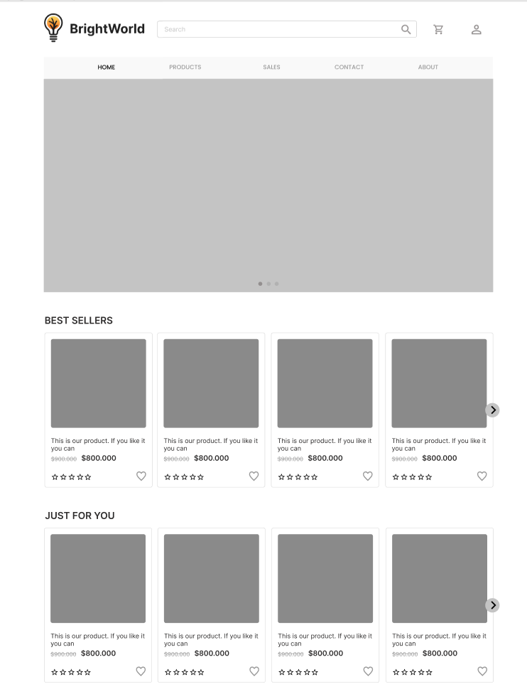

|  |  |  |
| --- | --- | --- |
|  | Prepared by (Student) | Approved by (Faculty) |
|  | Project Group No: 01 | PHAM THI LANH |
| Signature |  |  |
| Date |  |  |

|  |  |  |
| --- | --- | --- |
| **Design plan:** Bright World Limited | **Document name:** Screen shots | **SWD/Form:** No.05/SS/Ver1.0 |
| **Effective date:** | **Version:** 1.0 | **Page No:** 2 of 14 |

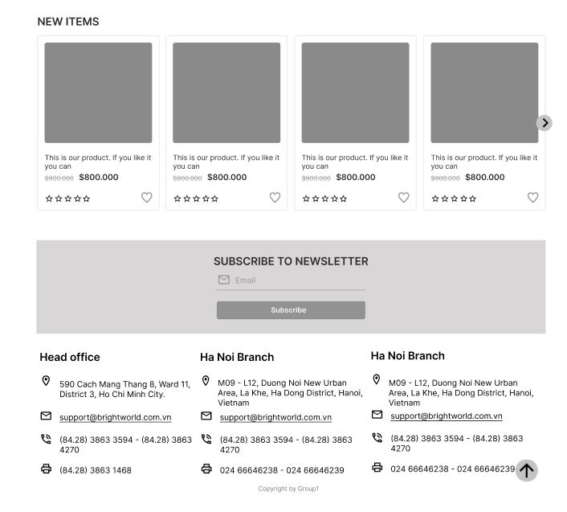

**Description:** This is a homepage of Bright World, the top of this page is a header, after that is a navigation bar. The main part of a homepage beside the slider also includes 3 sections: best sellers, just for you and new items. The footer of a homepage has 2 sections: subscribe and link to other information pages or contact information.

|  |  |  |
| --- | --- | --- |
|  | Prepared by (Student) | Approved by (Faculty) |
|  | Project Group No: 01 | PHAM THI LANH |
| Signature |  |  |
| Date |  |  |

|  |  |  |
| --- | --- | --- |
| **Design plan:** Bright World Limited | **Document name:** Screen shots | **SWD/Form:** No.05/SS/Ver1.0 |
| **Effective date:** | **Version:** 1.0 | **Page No:** 3 of 14 |

### Sign in



**Description:** When the user clicks on the human icon in the header, it leads to a sign in page. This form requires the user to enter an email address and a password. After clicking the login button, the user will be redirected to the homepage.

|  |  |  |
| --- | --- | --- |
|  | Prepared by (Student) | Approved by (Faculty) |
|  | Project Group No: 01 | PHAM THI LANH |
| Signature |  |  |
| Date |  |  |

|  |  |  |
| --- | --- | --- |
| **Design plan:** Bright World Limited | **Document name:** Screen shots | **SWD/Form:** No.05/SS/Ver1.0 |
| **Effective date:** | **Version:** 1.0 | **Page No:** 4 of 14 |

### Sign up

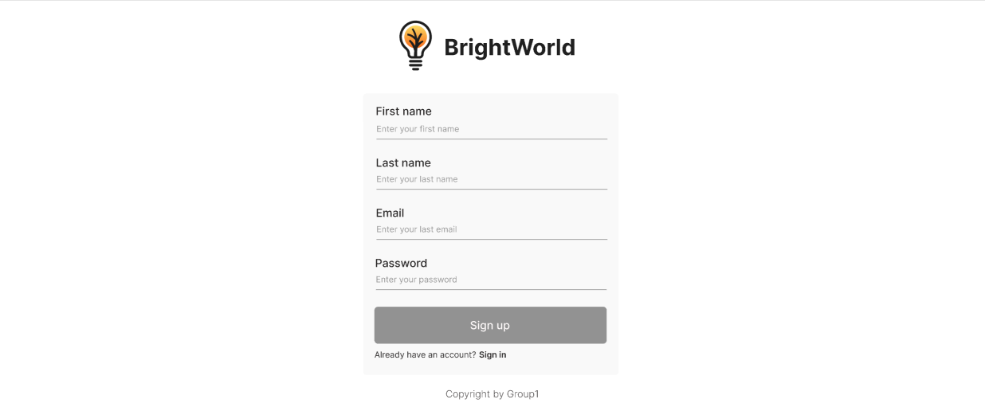

**Description:** If the user hasn’t created an account, he/she can click to Create new account in the sign in page and it will lead to this sign up page. This sign up form requires the user to enter 4 fields: first name, last name, email and password. After clicking the sign up button the user will be redirected to the homepage.

|  |  |  |
| --- | --- | --- |
|  | Prepared by (Student) | Approved by (Faculty) |
|  | Project Group No: 01 | PHAM THI LANH |
| Signature |  |  |
| Date |  |  |

|  |  |  |
| --- | --- | --- |
| **Design plan:** Bright World Limited | **Document name:** Screen shots | **SWD/Form:** No.05/SS/Ver1.0 |
| **Effective date:** | **Version:** 1.0 | **Page No:** 5 of 14 |

### Sales

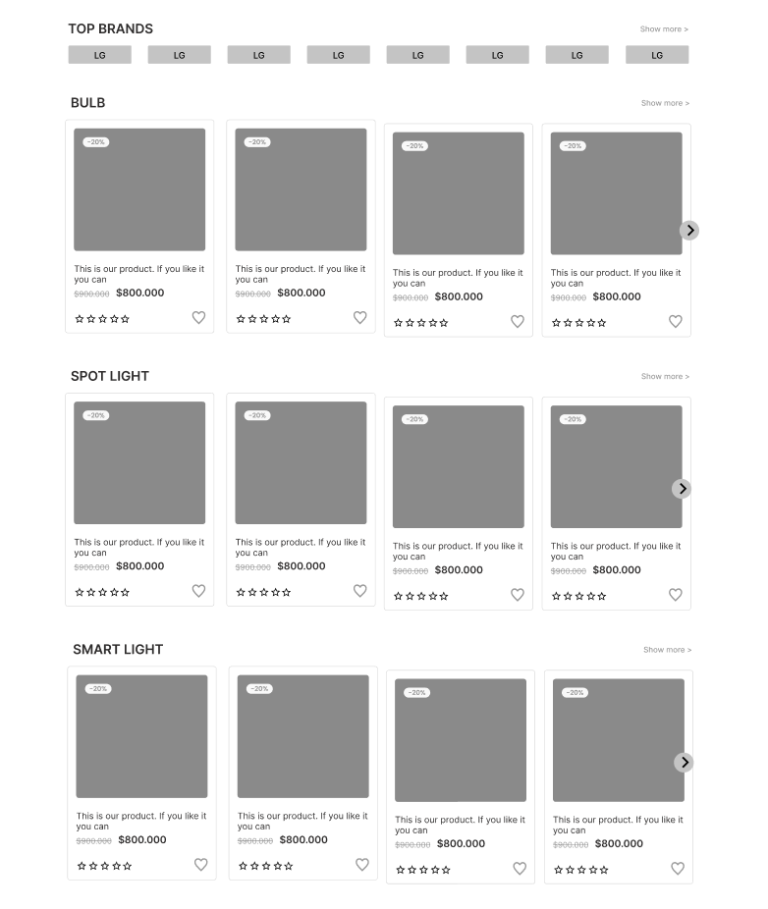

**Description:** When the user clicks on the Sales tag in navigation, it will lead to this page. The main part of this page contains 2 sections: top brands, and sale items (which includes the category of each product).

|  |  |  |
| --- | --- | --- |
|  | Prepared by (Student) | Approved by (Faculty) |
|  | Project Group No: 01 | PHAM THI LANH |
| Signature |  |  |
| Date |  |  |

|  |  |  |
| --- | --- | --- |
| **Design plan:** Bright World Limited | **Document name:** Screen shots | **SWD/Form:** No.05/SS/Ver1.0 |
| **Effective date:** | **Version:** 1.0 | **Page No:** 6 of 14 |

### Product Category/Search Page

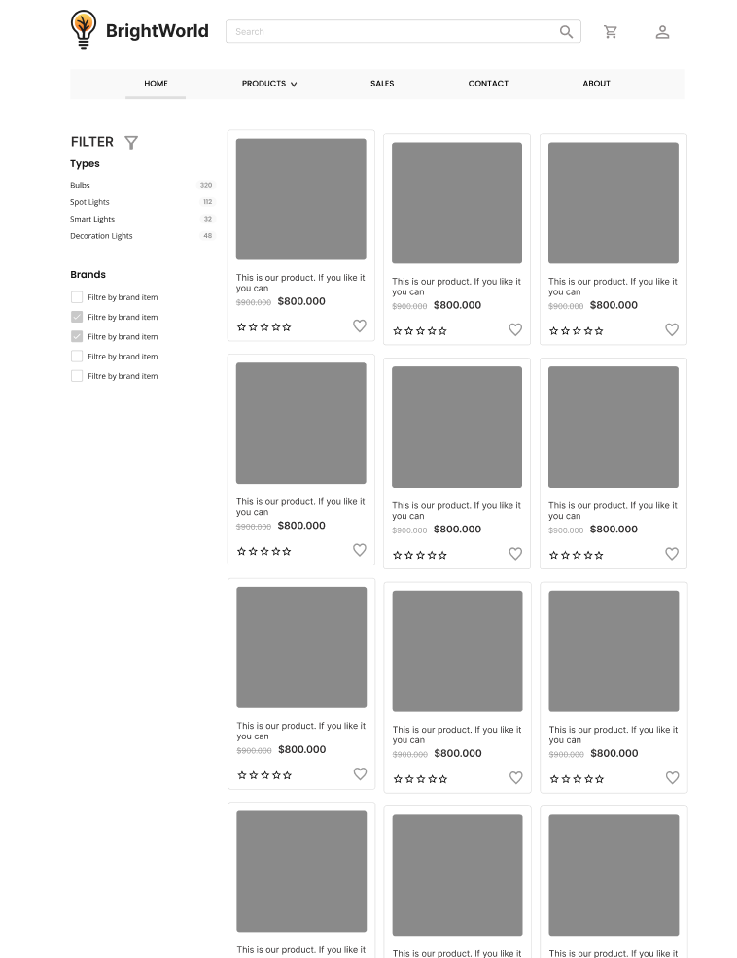

**Description:** When the user clicks on a specific category in the sub menu of the Products tag on navigation, it will lead to this page. The left part is a filter which contains filters by: light types, brands, rating and price. The right part is a result of a specific product.

|  |  |  |
| --- | --- | --- |
|  | Prepared by (Student) | Approved by (Faculty) |
|  | Project Group No: 01 | PHAM THI LANH |
| Signature |  |  |
| Date |  |  |

|  |  |  |
| --- | --- | --- |
| **Design plan:** Bright World Limited | **Document name:** Screen shots | **SWD/Form:** No.05/SS/Ver1.0 |
| **Effective date:** | **Version:** 1.0 | **Page No:** 7 of 14 |

### Product Comparison

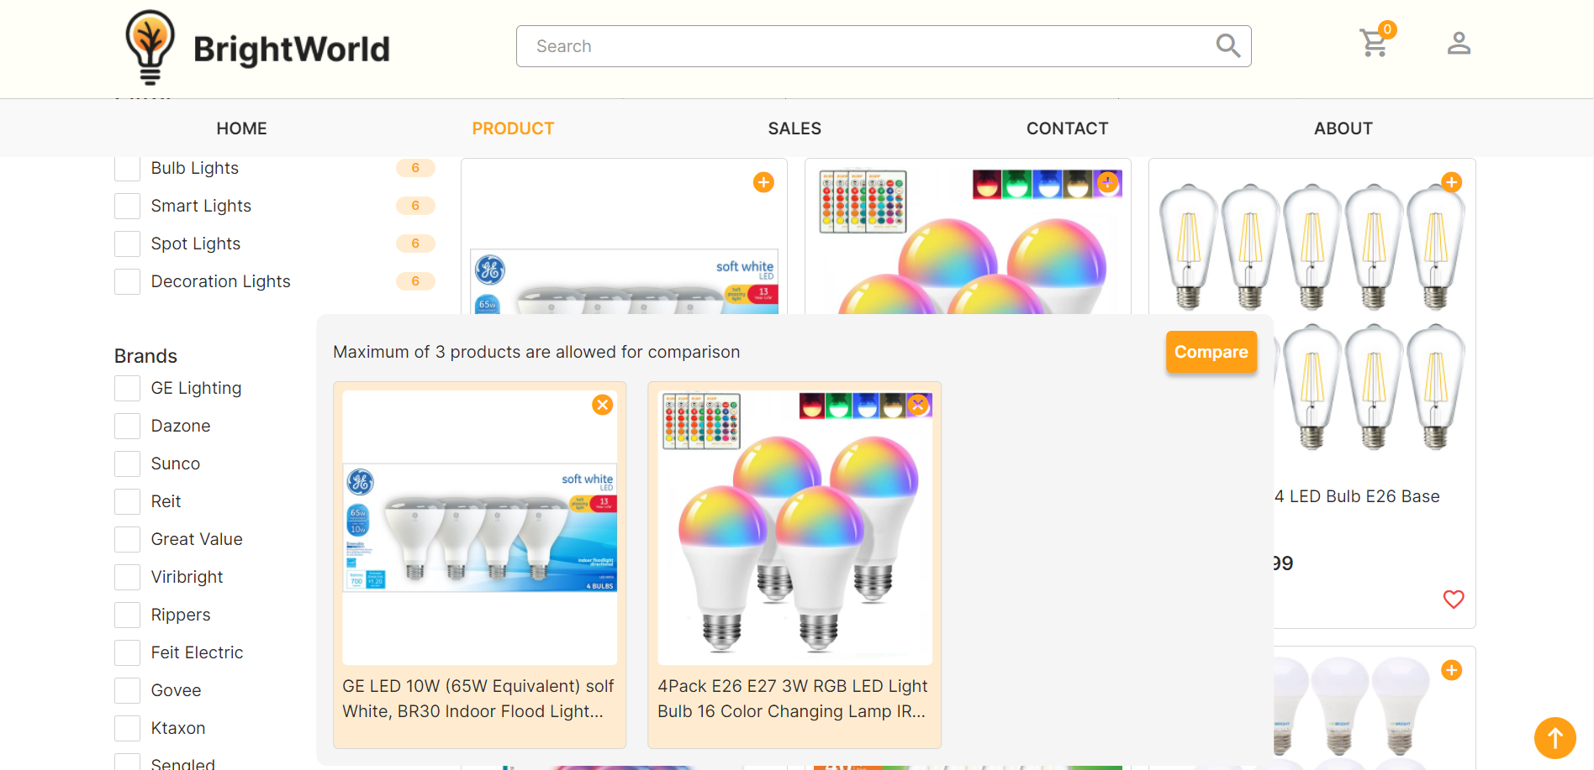

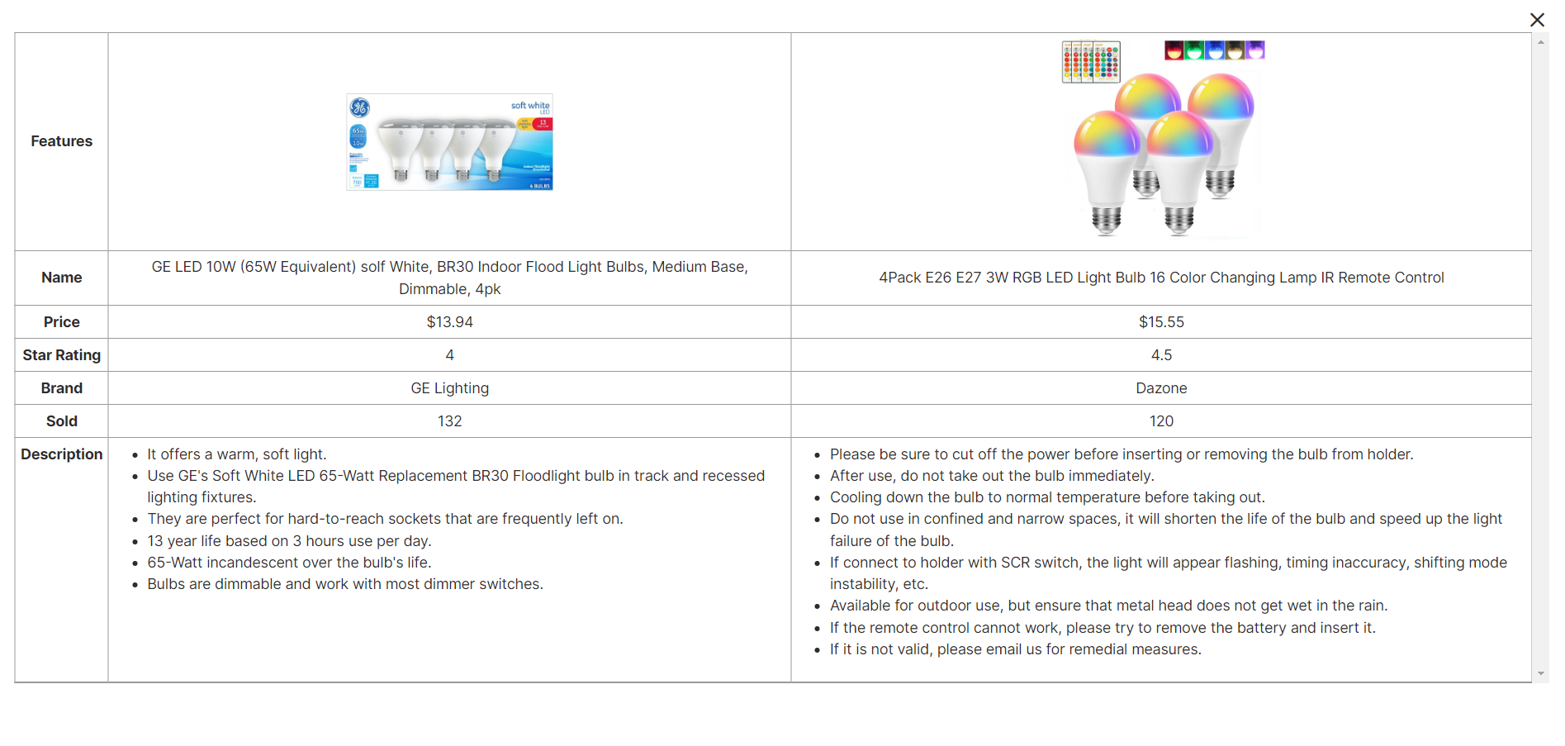

**Description:** When the user clicks on add icon on specific product, this product will be added to comparison, at least 2 items and less than 4 items can be compared. When the user clicks on compare button, a compare modal will appear, it shows detail information of those items

|  |  |  |
| --- | --- | --- |
|  | Prepared by (Student) | Approved by (Faculty) |
|  | Project Group No: 01 | PHAM THI LANH |
| Signature |  |  |
| Date |  |  |

|  |  |  |
| --- | --- | --- |
| **Design plan:** Bright World Limited | **Document name:** Screen shots | **SWD/Form:** No.05/SS/Ver1.0 |
| **Effective date:** | **Version:** 1.0 | **Page No:** 7 of 14 |

### Product Detail

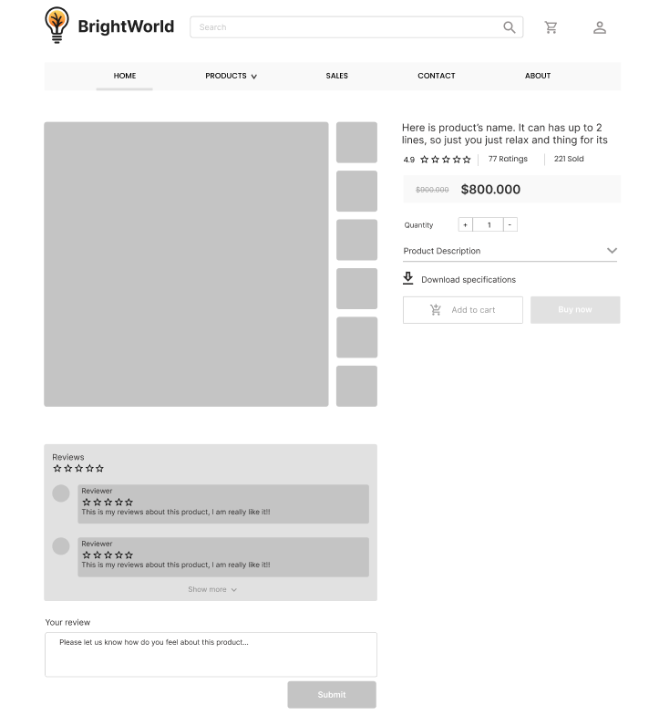

|  |  |  |
| --- | --- | --- |
|  | Prepared by (Student) | Approved by (Faculty) |
|  | Project Group No: 01 | PHAM THI LANH |
| Signature |  |  |
| Date |  |  |

|  |  |  |
| --- | --- | --- |
| **Design plan:** Bright World Limited | **Document name:** Screen shots | **SWD/Form:** No.05/SS/Ver1.0 |
| **Effective date:** | **Version:** 1.0 | **Page No:** 8 of 14 |

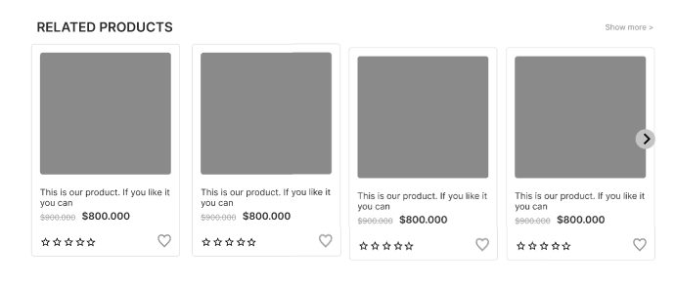

**Description:** When the user clicks on a specific product it will lead to this product detail page. Beside in detail information about the product, it also contains Call to Action buttons Buy now. Moreover, it also contains the Reviews part, this includes reviews of the other buyers, and the user can write reviews about this product. The last part of this page is the Related Products section.

|  |  |  |
| --- | --- | --- |
|  | Prepared by (Student) | Approved by (Faculty) |
|  | Project Group No: 01 | PHAM THI LANH |
| Signature |  |  |
| Date |  |  |

|  |  |  |
| --- | --- | --- |
| **Design plan:** Bright World Limited | **Document name:** Screen shots | **SWD/Form:** No.05/SS/Ver1.0 |
| **Effective date:** | **Version:** 1.0 | **Page No:** 9 of 14 |

### Cart Dropdown

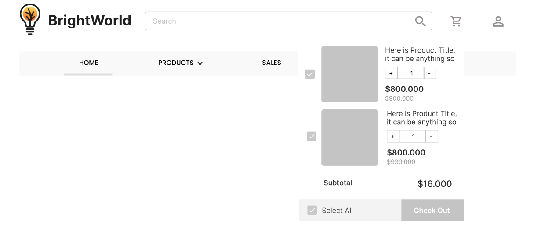

**Description:** When the user clicks on the cart icon in the header, the cart information will appear. It includes products that users have already added to cart, the user can select all items or remove items which they don’t have the intention to buy.

|  |  |  |
| --- | --- | --- |
|  | Prepared by (Student) | Approved by (Faculty) |
|  | Project Group No: 01 | PHAM THI LANH |
| Signature |  |  |
| Date |  |  |

|  |  |  |
| --- | --- | --- |
| **Design plan:** Bright World Limited | **Document name:** Screen shots | **SWD/Form:** No.05/SS/Ver1.0 |
| **Effective date:** | **Version:** 1.0 | **Page No:** 10 of 14 |

### Check out

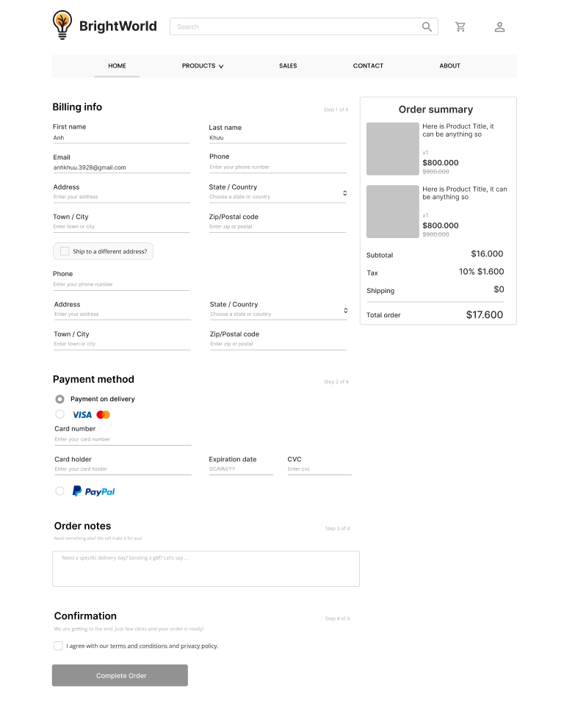

|  |  |  |
| --- | --- | --- |
|  | Prepared by (Student) | Approved by (Faculty) |
|  | Project Group No: 01 | PHAM THI LANH |
| Signature |  |  |
| Date |  |  |

|  |  |  |
| --- | --- | --- |
| **Design plan:** Bright World Limited | **Document name:** Screen shots | **SWD/Form:** No.05/SS/Ver1.0 |
| **Effective date:** | **Version:** 1.0 | **Page No:** 11 of 14 |

**Description:** After clicking the Check out button on the Cart or Buy now button in Product Detail Page, the user will be redirected to this checkout page. The left part of this page contains a form which requires the user to enter and the other side is the Order summary.

|  |  |  |
| --- | --- | --- |
|  | Prepared by (Student) | Approved by (Faculty) |
|  | Project Group No: 01 | PHAM THI LANH |
| Signature |  |  |
| Date |  |  |

|  |  |  |
| --- | --- | --- |
| **Design plan:** Bright World Limited | **Document name:** Screen shots | **SWD/Form:** No.05/SS/Ver1.0 |
| **Effective date:** | **Version:** 1.0 | **Page No:** 12 of 14 |

### Contact

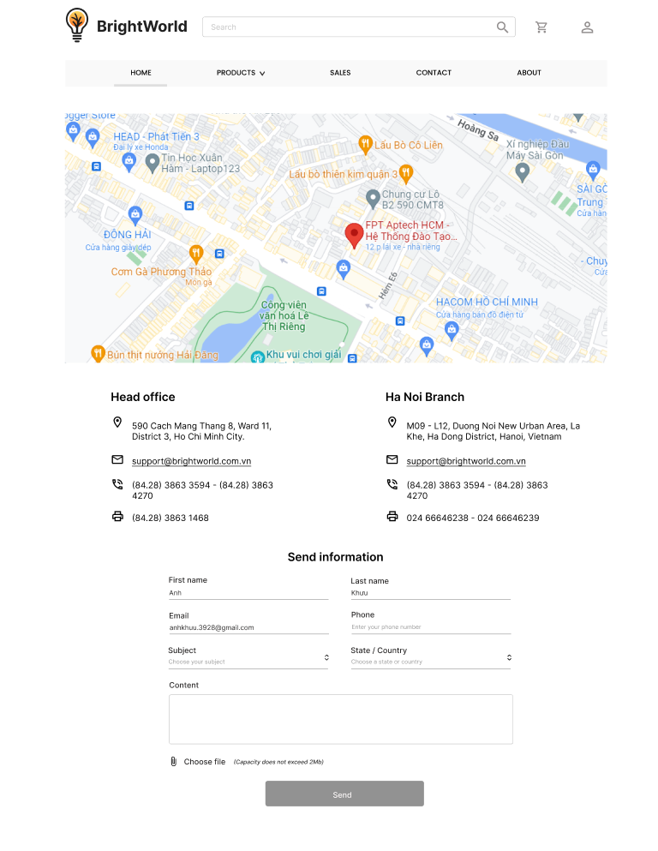

|  |  |  |
| --- | --- | --- |
|  | Prepared by (Student) | Approved by (Faculty) |
|  | Project Group No: 01 | PHAM THI LANH |
| Signature |  |  |
| Date |  |  |

|  |  |  |
| --- | --- | --- |
| **Design plan:** Bright World Limited | **Document name:** Screen shots | **SWD/Form:** No.05/SS/Ver1.0 |
| **Effective date:** | **Version:** 1.0 | **Page No:** 13 of 14 |

**Description:** After clicking the Contact tag on the navigation bar, the user will be redirected to this page. The first part of this page is a map, beside it is a detailed location of Bright World’s Branches. The last part of this page is a Send information form to send their information to Bright World.

|  |  |  |
| --- | --- | --- |
|  | Prepared by (Student) | Approved by (Faculty) |
|  | Project Group No: 01 | PHAM THI LANH |
| Signature |  |  |
| Date |  |  |

|  |  |  |
| --- | --- | --- |
| **Design plan:** Bright World Limited | **Document name:** Screen shots | **SWD/Form:** No.05/SS/Ver1.0 |
| **Effective date:** | **Version:** 1.0 | **Page No:** 14 of 14 |

### About

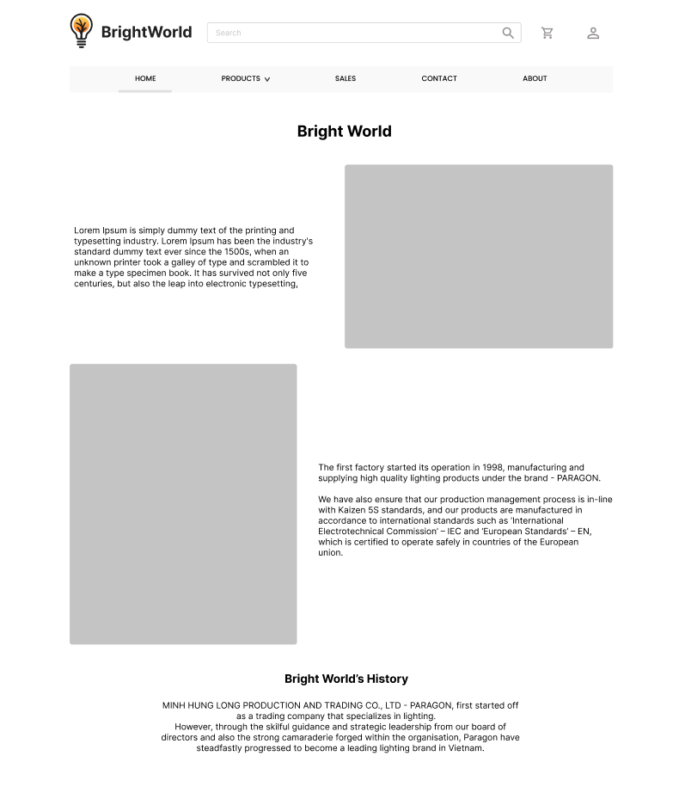

**Description:** After the user clicks on the About tag on the navigation bar, it will lead to this about page. This page contains detailed information about Bright World.

|  |  |  |
| --- | --- | --- |
|  | Prepared by (Student) | Approved by (Faculty) |
|  | Project Group No: 01 | PHAM THI LANH |
| Signature |  |  |
| Date |  |  |

## Task Sheet

|  |  |  |  |  |  |  |
| --- | --- | --- | --- | --- | --- | --- |
| **Project Ref No.** | **Project Title – Ask Me Mobile** | **Activity Plan Prepared by** | **Date of preparation of Activity Plan** | | | |
| **Task** | **Actual Start Date** | **Actual Days** | **Teammate Names** | **Status** |
| Brainstorming ideas for layouts and Project Object | | Nam, Sơn, Anh | 30/03/2022 | 1 days | Nam, Sơn, Anh | Completed |
| Draw site maps and architecture design | | Nam, Sơn, Anh | 30/03/2022 | 1 days | Nam, Sơn, Anh | Completed |
| Wire framing general page layout | | Anh | 02/04/2022 | 3 days | Anh | Completed |
| Collect static assets (pictures, mp4, documentation,…) | | Nam, Sơn | 02/04/2022 | 5 days | Nam, Sơn | Completed |

# Review 2

### Homepage

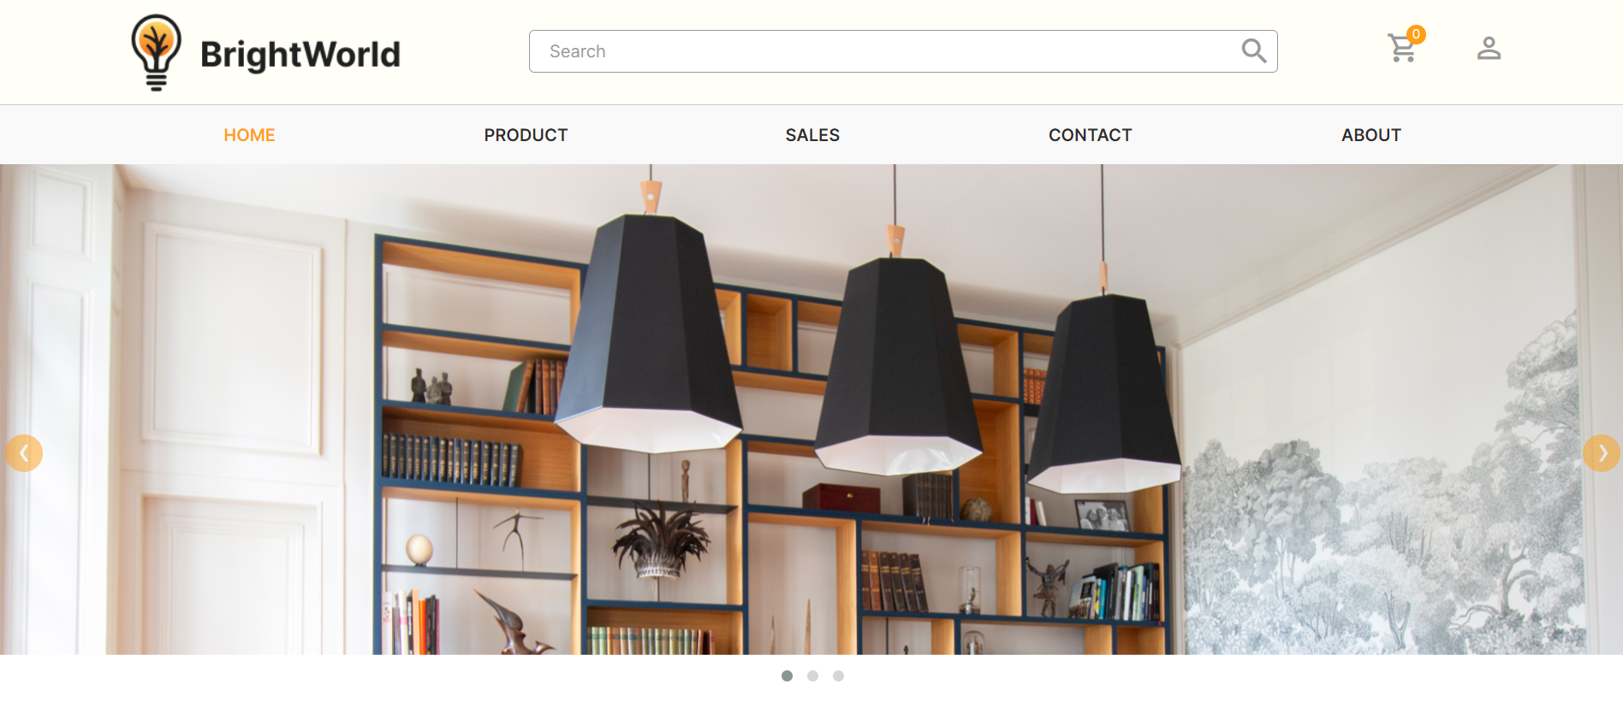

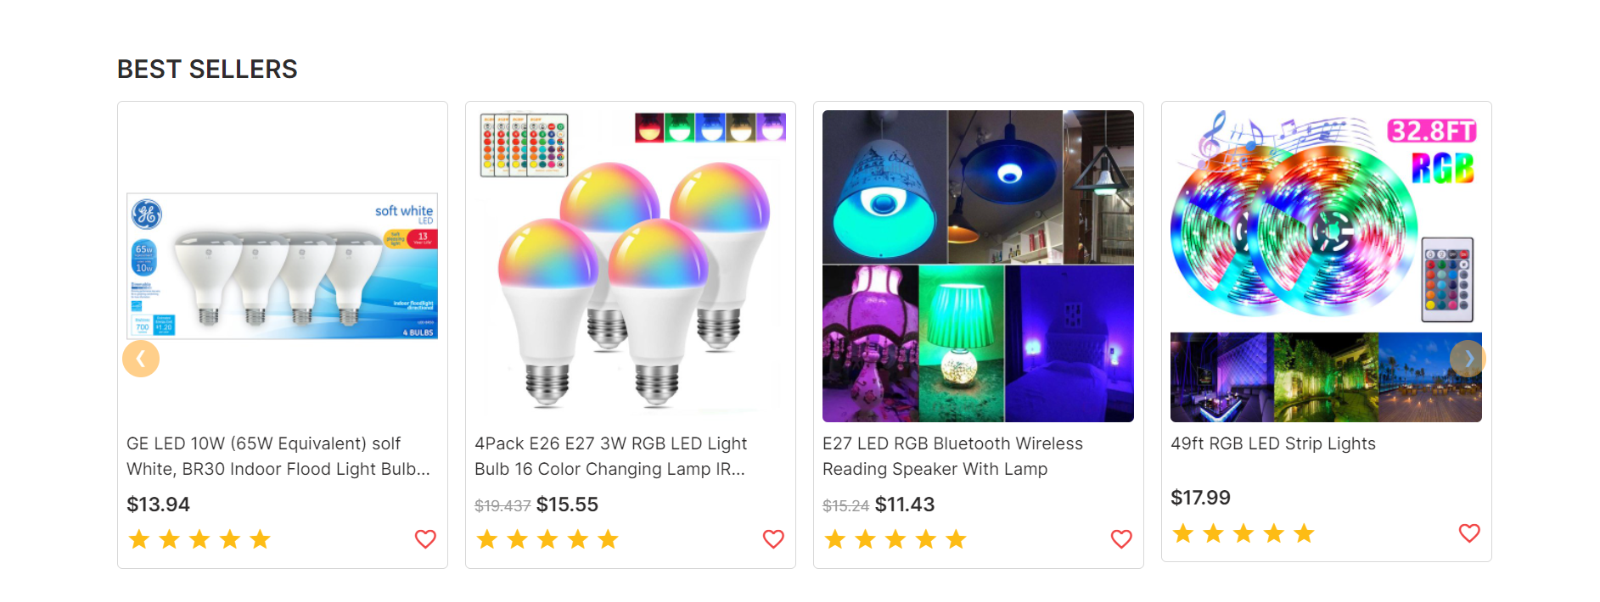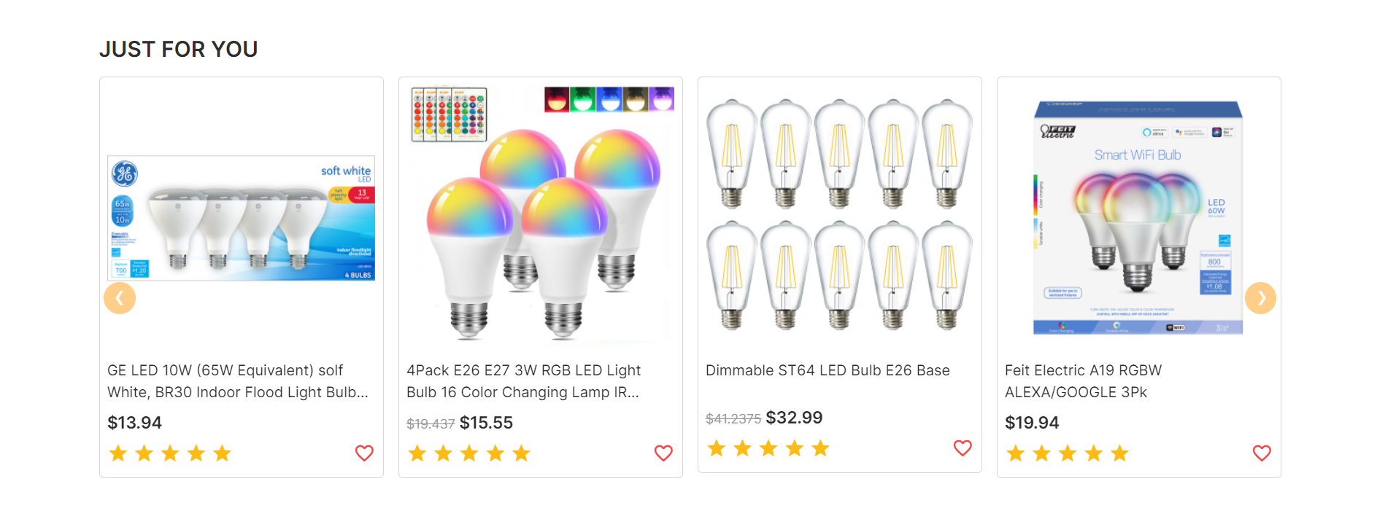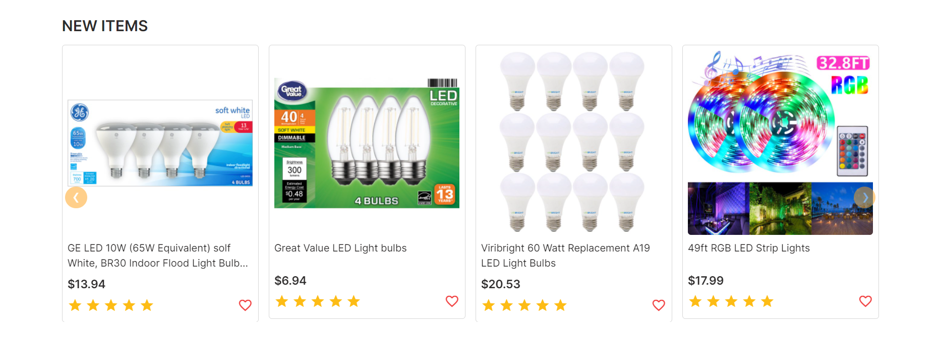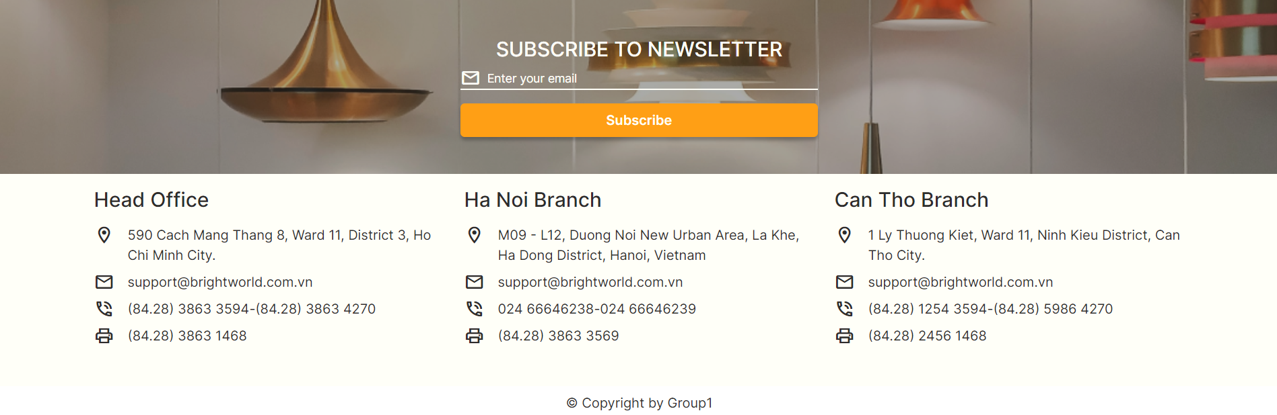

### Sign in

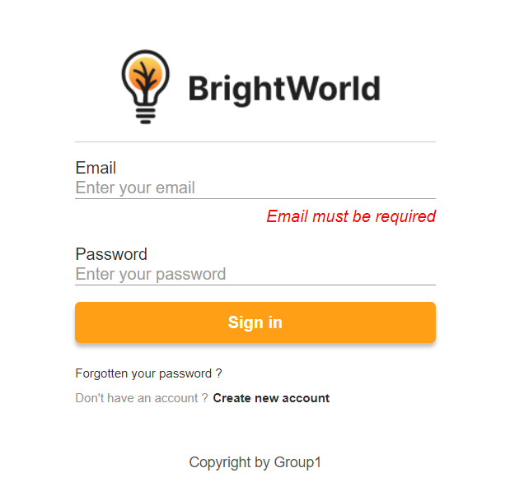

### Sign up

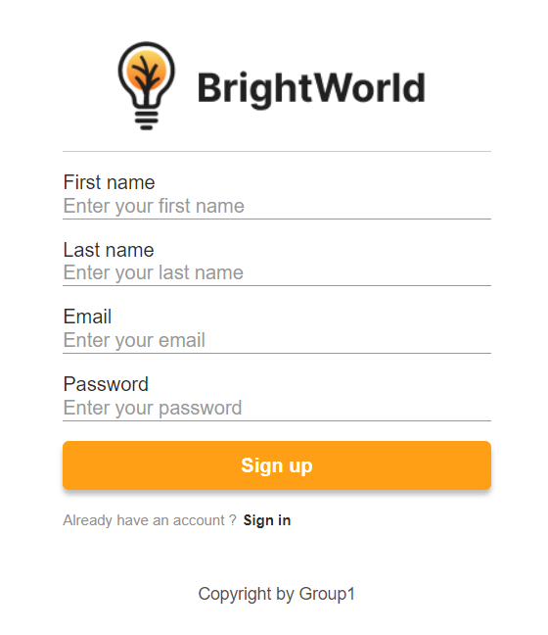

### Sales

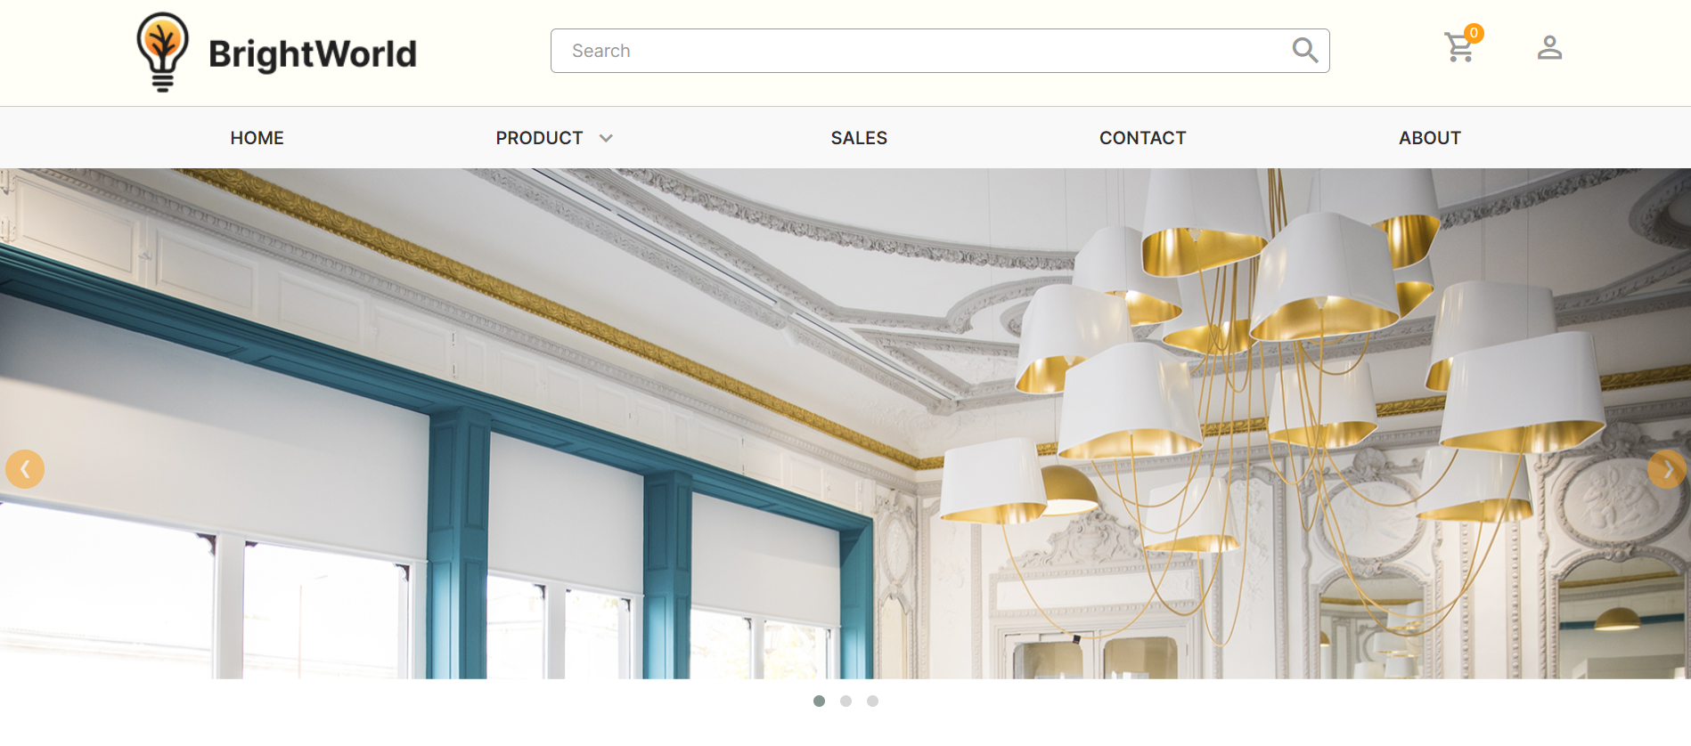

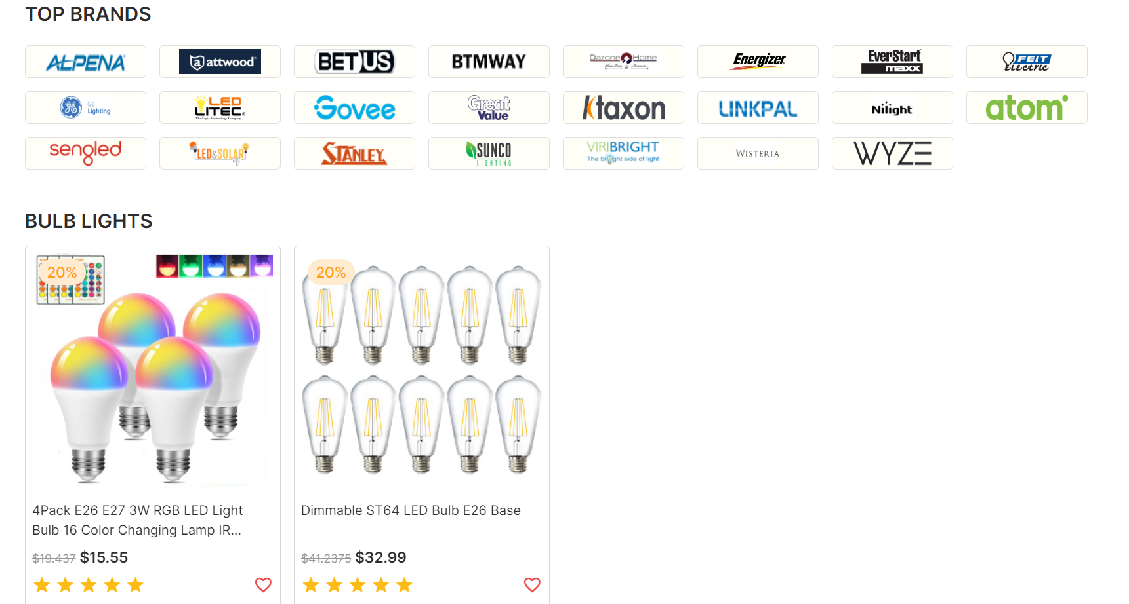

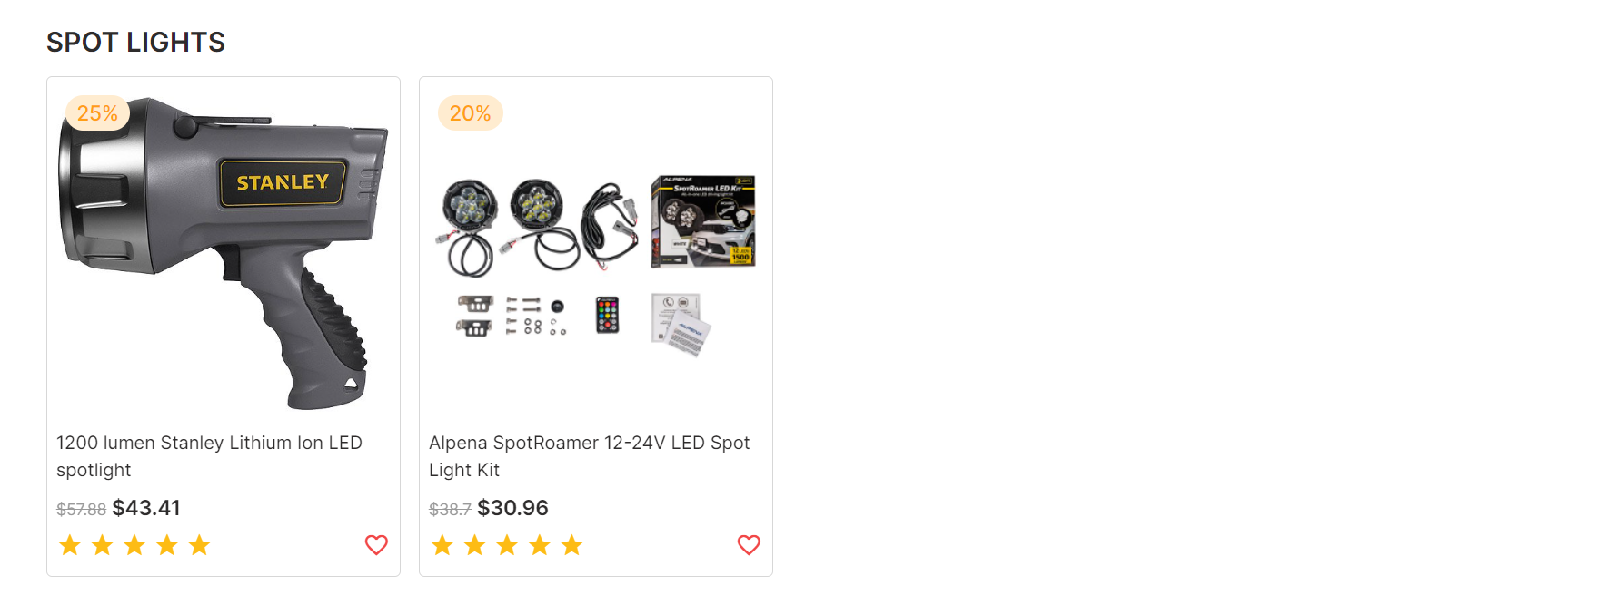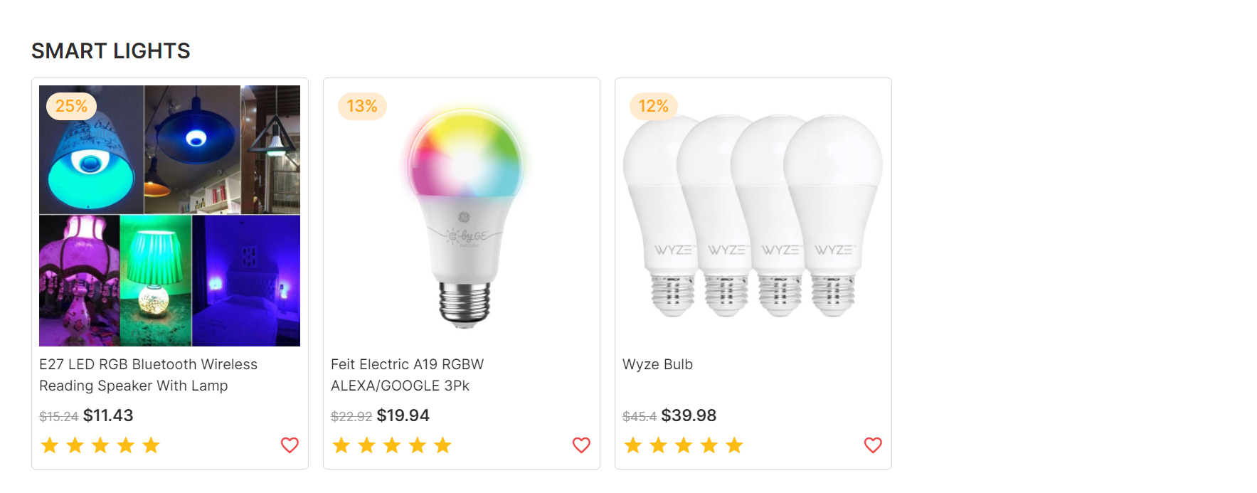

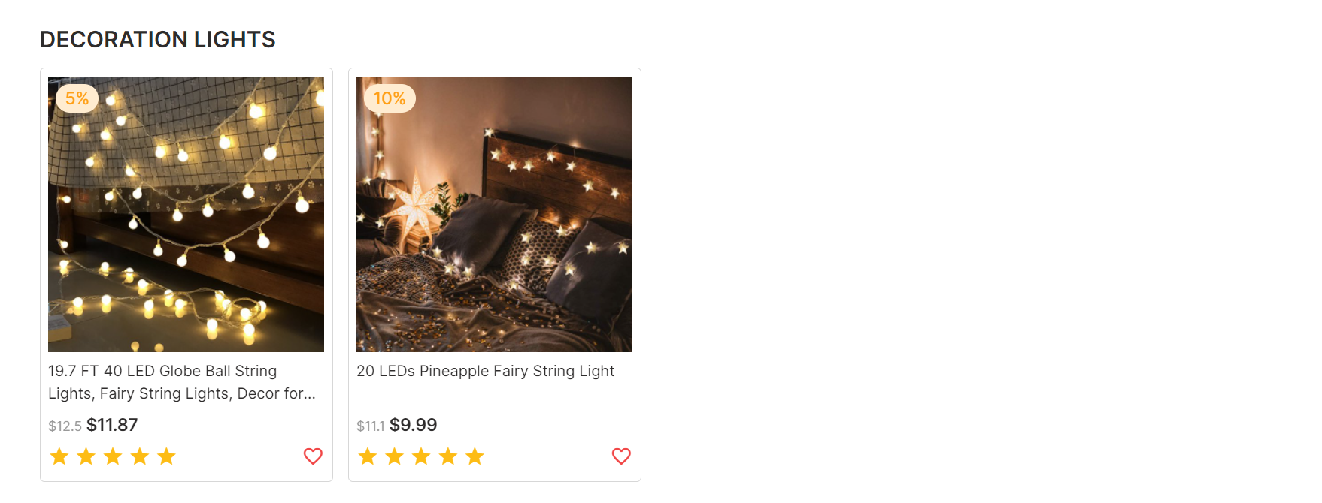

### Product Category/Search Page

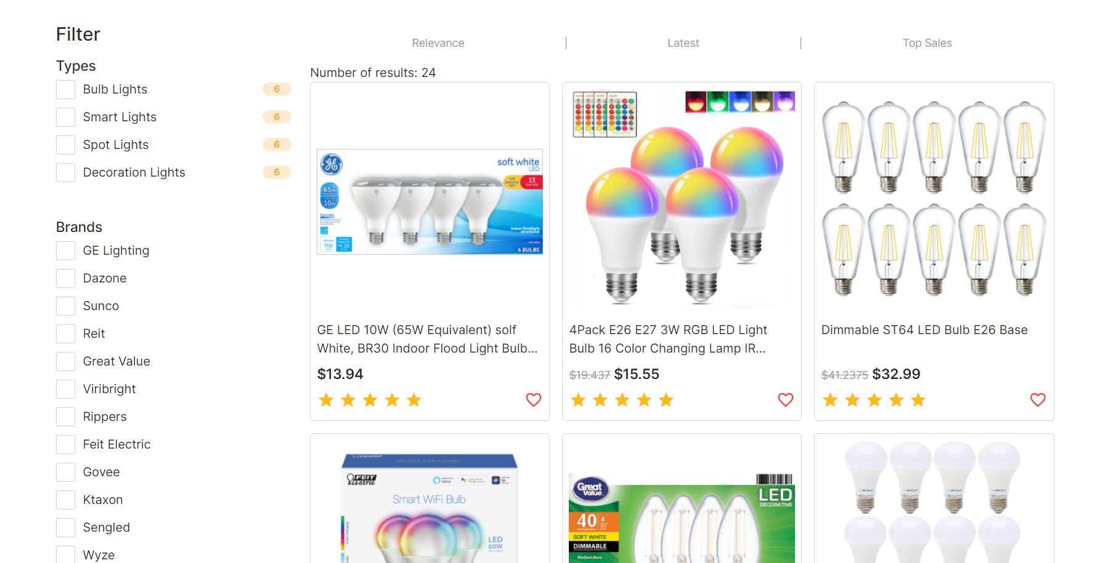

### Product Comparison





### Product Detail

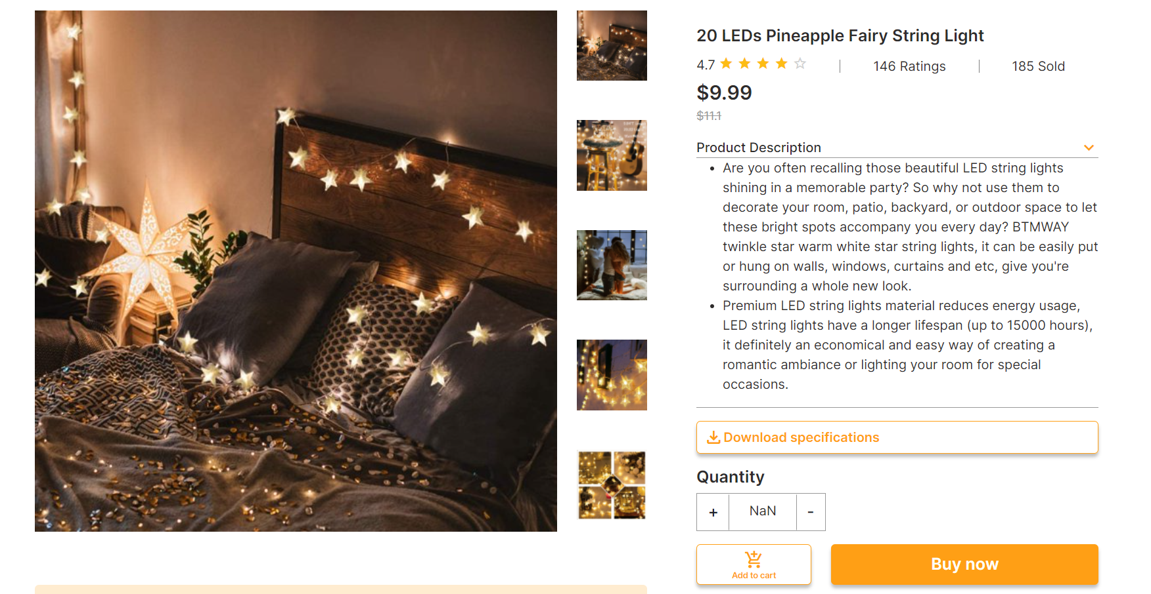

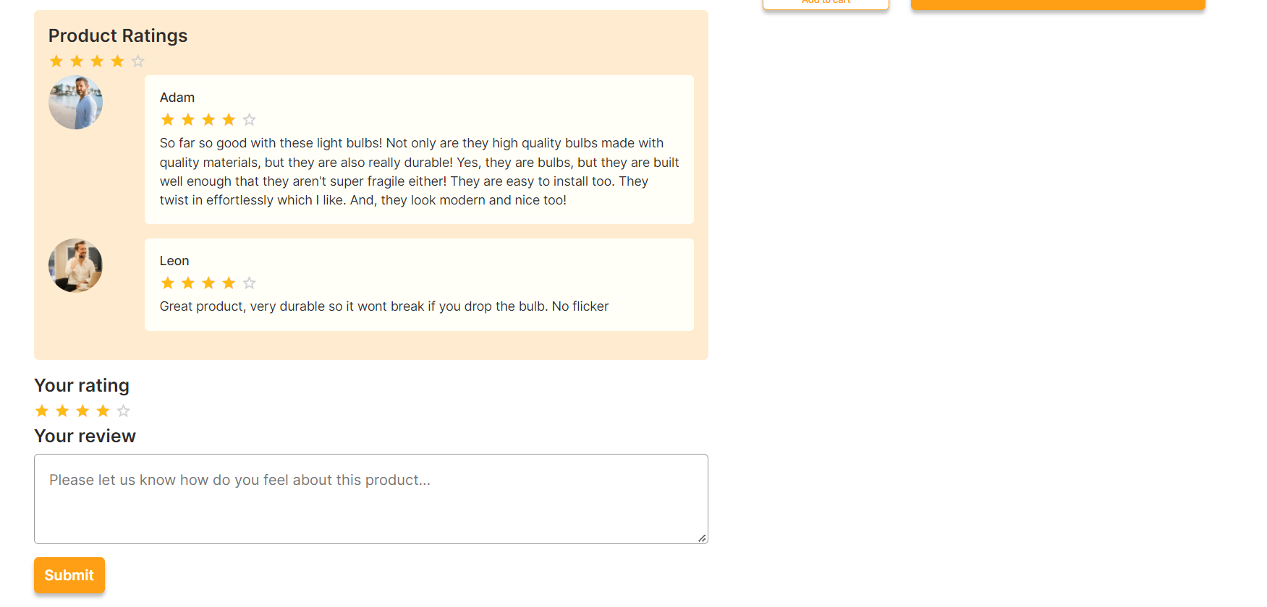

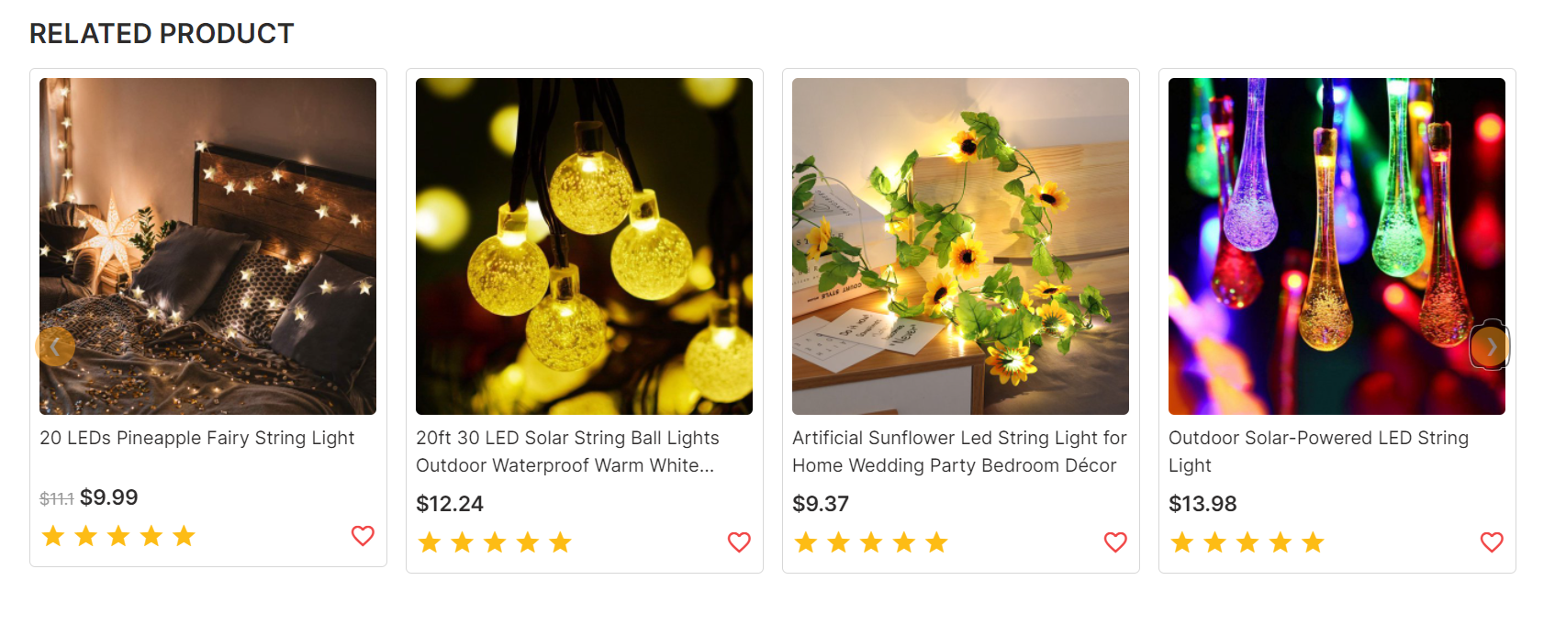

### Cart Dropdown

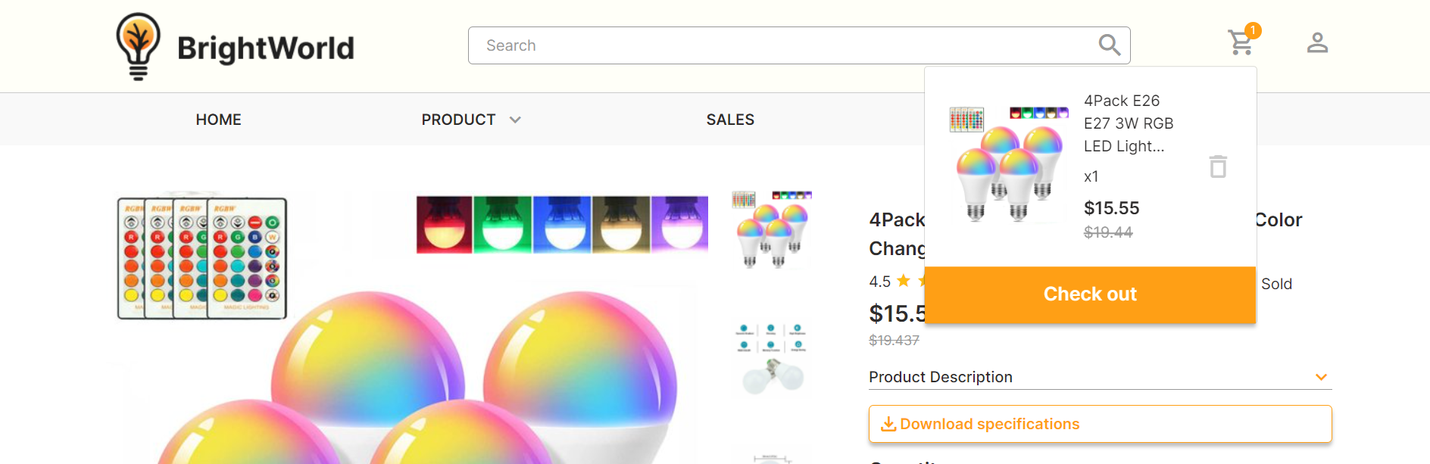

### Check out

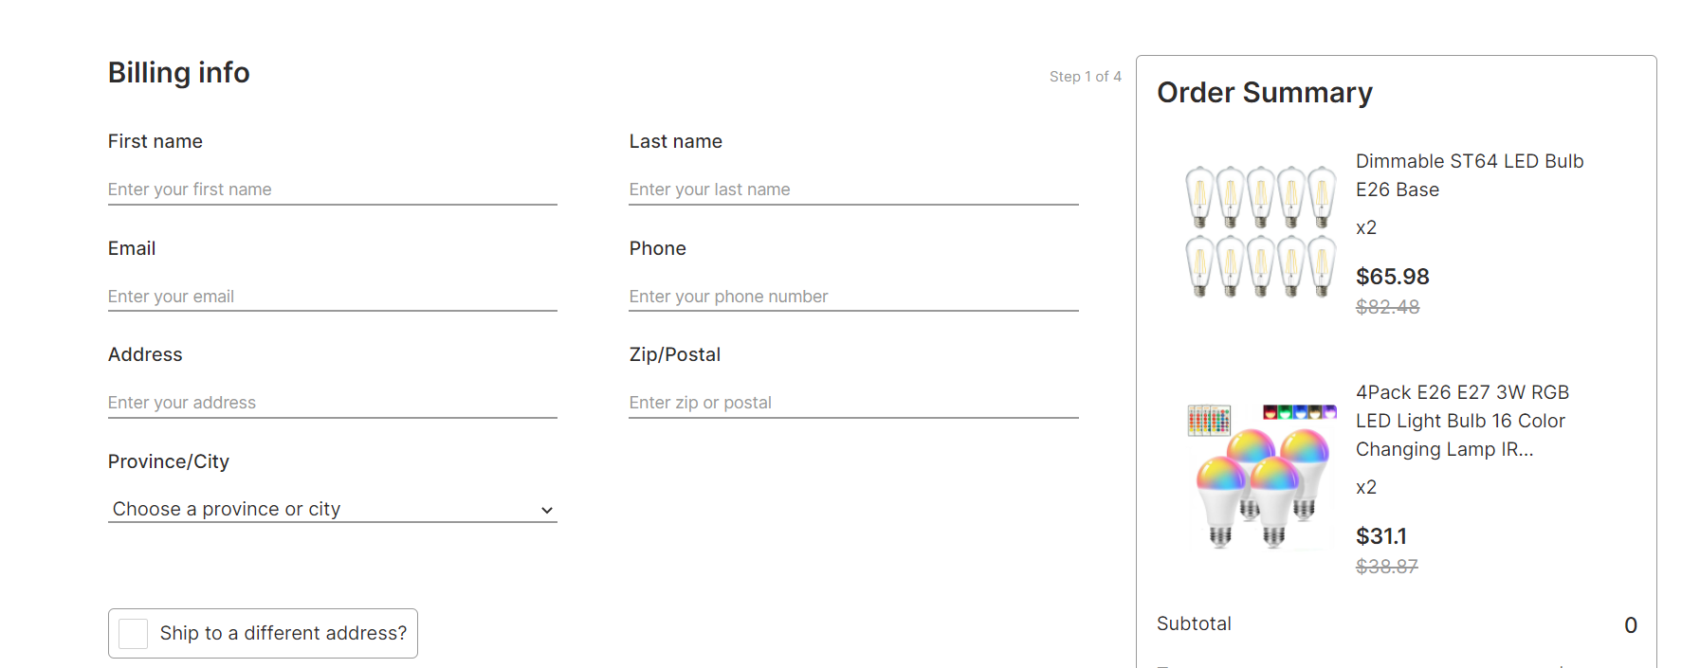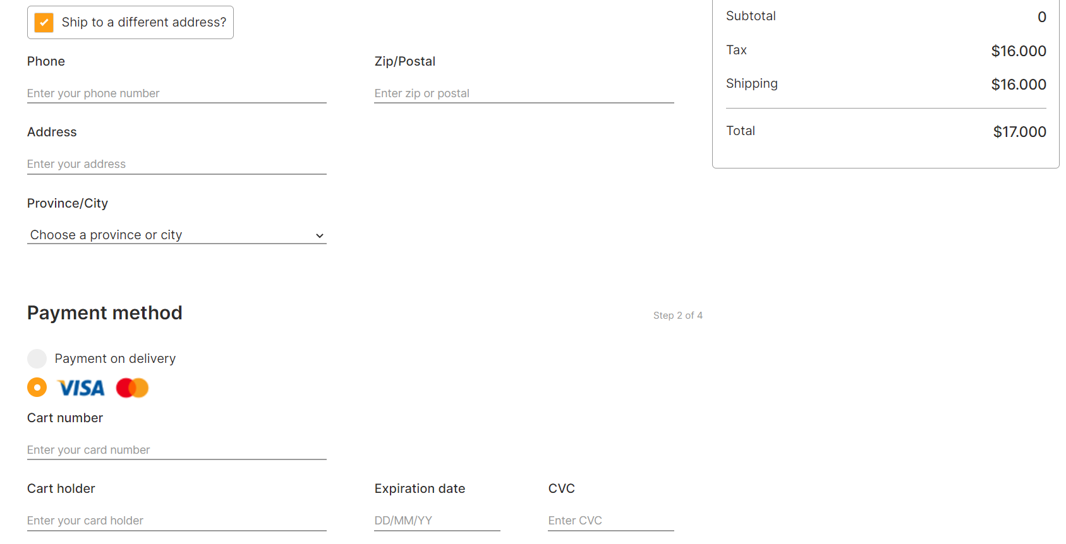

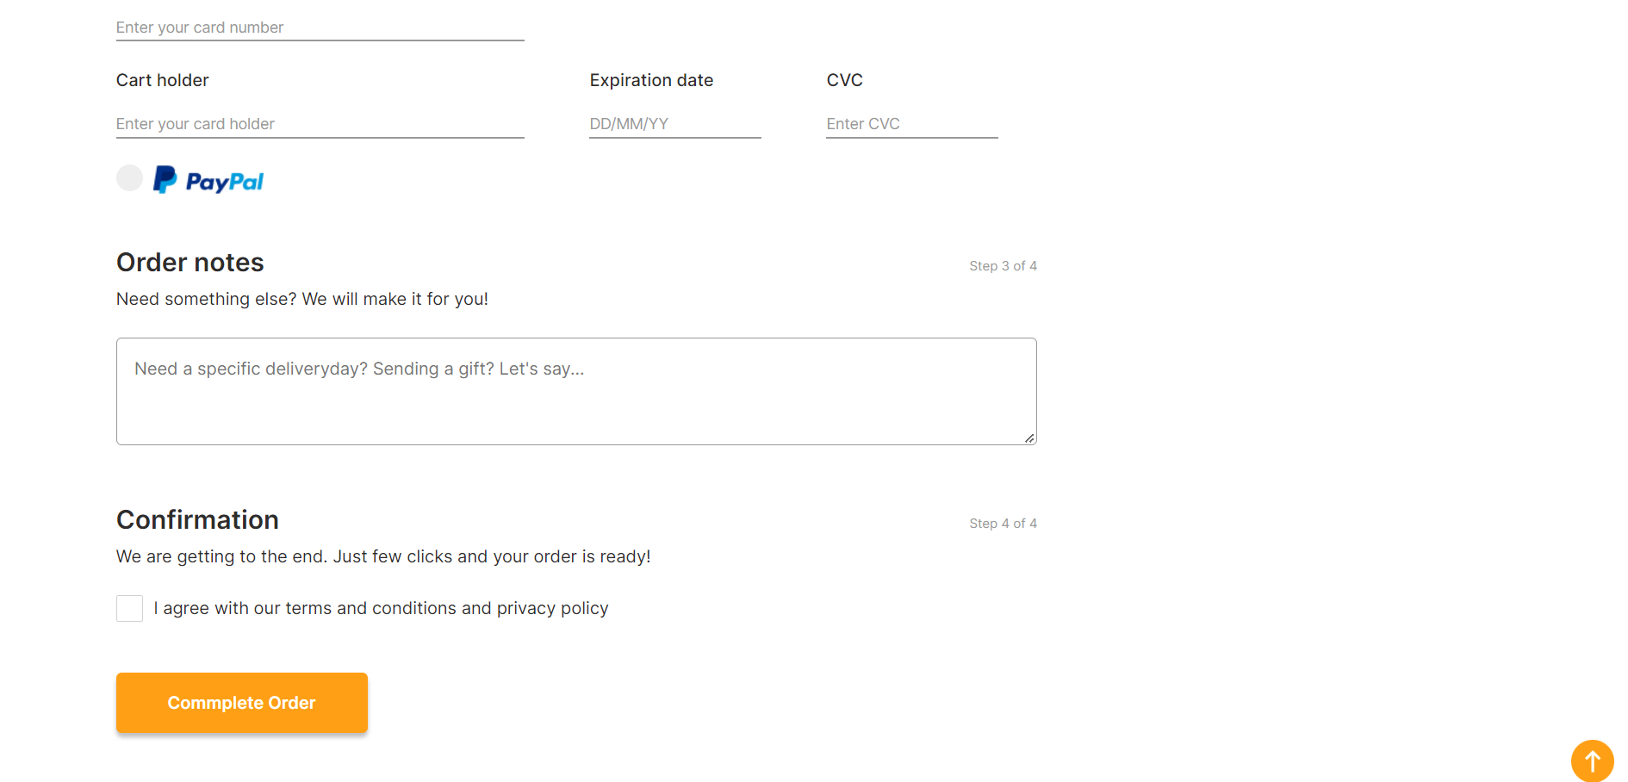

### Contact

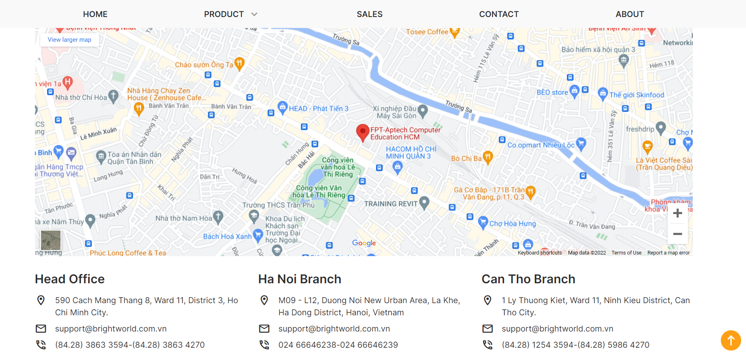

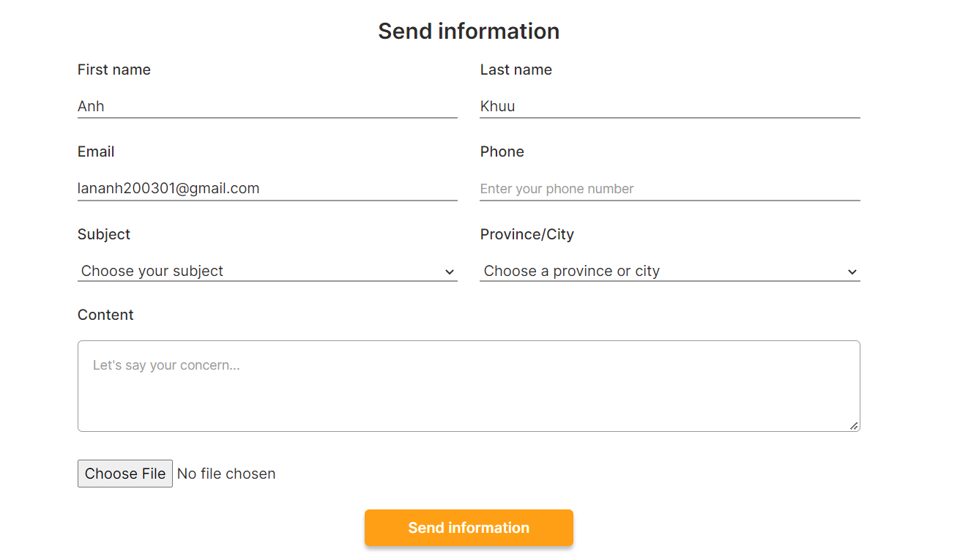

### About

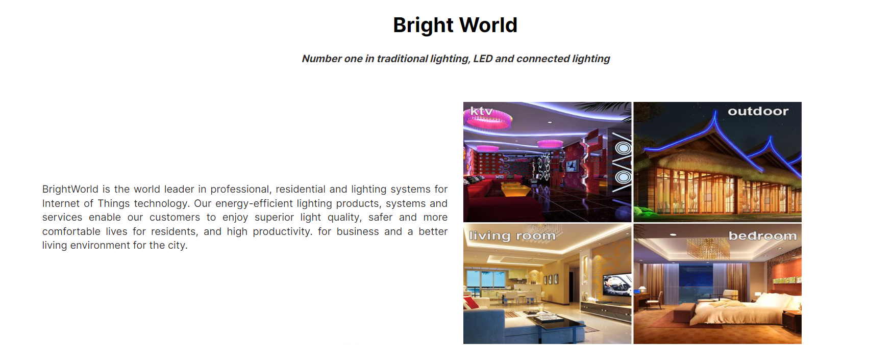

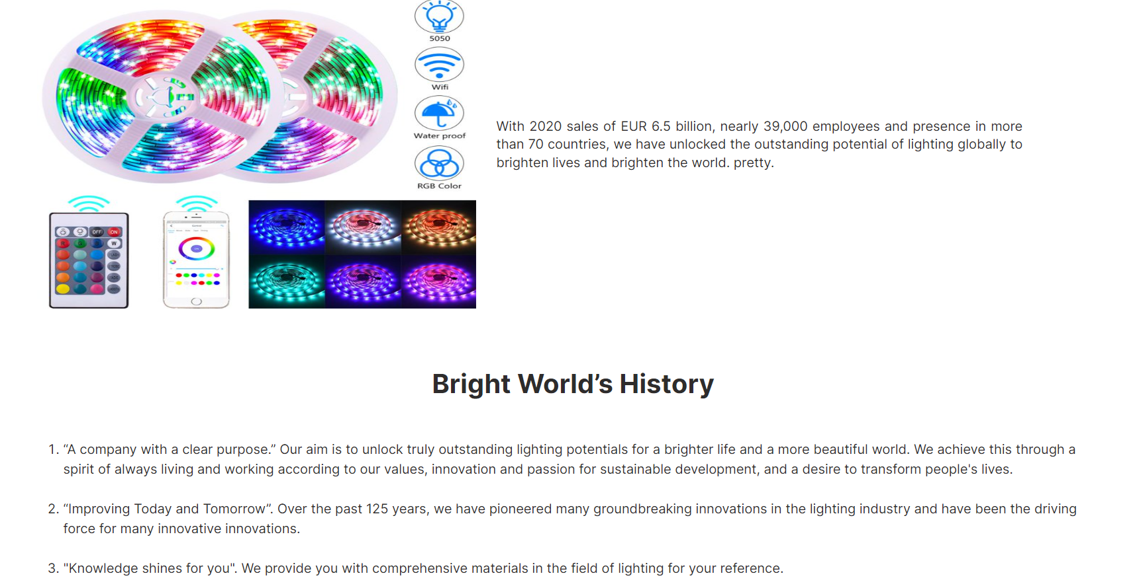

## Task Sheet

|  |  |  |  |  |  |  |
| --- | --- | --- | --- | --- | --- | --- |
| **Project Ref No.** | **Project Title – Ask Me Mobile** | **Activity Plan Prepared by** | **Date of preparation of Activity Plan** | | | |
| **Task** | **Actual Start Date** | **Actual Days** | **Teammate Names** | **Status** |
| Brainstorming ideas for layouts and Project Object | | Nam, Sơn, Anh | 30/03/2022 | 1 days | Nam, Sơn, Anh | Completed |
| Draw site maps and architecture design | | Nam, Sơn, Anh | 30/03/2022 | 1 days | Nam, Sơn, Anh | Completed |
| Wire framing general page layout | | Anh | 02/04/2022 | 3 days | Anh | Completed |
| Collect static assets (pictures, mp4, documentation,…) | | Nam, Sơn | 02/04/2022 | 5 days | Nam, Sơn | Completed |
| Design & Build Homepage | | Anh | 06/04/2022 | 8 days | Anh | Completed |
| Design & Build Sign in | | Nam | 06/04/2022 | 5 days | Nam | Completed |
| Design & Build Sign up | | Nam | 06/04/2022 | 5 days | Nam | Completed |
| Design & Build Sales | | Anh | 10/04/2022 | 3 days | Anh | Completed |
| Design & Build Product Category/Search Page | | Anh | 12/04/2022 | 5 days | Anh | Completed |
| Design & Build Product Detail | | Anh | 15/04/2022 | 4 days | Anh | Completed |
| Design & Build Cart Dropdown | | Anh | 17/04/2022 | 2 days | Anh | Completed |
| Design & Build Check out | | Sơn | 06/04/2022 | 5 days | Sơn | Completed |
| Design & Build Contact | | Sơn | 10/04/2022 | 5 days | Sơn | Completed |
| Design & Build About | | Nam | 10/04/2022 | 3 days | Nam | Completed |
| Product Comparison | | Anh | 04/04/2022 | 1 days | Anh | Completed |
| Write Project Report | | Sơn, Anh | 19/04/2022 | 1 days | Sơn, Anh | Completed |

## Testing document

|  |  |  |  |  |
| --- | --- | --- | --- | --- |
| **Sr.No** | **Features Tested** | | | **Remarks** |
| 1 | Are all the users able to view the images and links? | | | OK |
| 2 | Have all the views, modules and controllers been | |  | OK |
| properly integrated and is the site function as a single | | |
| page application? | |  |
| 3 | Are the GUI content devoid of spelling mistakes? | | | OK |
| 4 | Is the application user-friendly? | | | OK |
| 5 | Is the Website launching correctly in all popular | |  | OK |
| browsers? |  |  |
| 6 | Are all the forms validated with proper criteria? | | | OK |
| 7 | Do all text links lead to the appropriate website? | | | OK |
| 8 | Do all image links lead to the appropriate website? | | | OK |
| 9 | Are all the images and links clearly visible on the page? | | | OK |
| 10 | Does the Web page work properly in all the tested | |  | OK |
| browsers? |  |  |
| 11 | Does the Web page take too long to be loaded fully? | | | OK |
| 12 | Is the navigation sequences correct through all the Web | | | OK |
| pages on the site? | |  |
| 13 | Is the JavaScript code working as expected in all click | | | OK |

## Final checklist

|  |  |  |  |  |
| --- | --- | --- | --- | --- |
| **Sr.No** | **Features Tested** | | | **Remarks** |
| 1 | Are all the users able to view the images and links? | | | OK |
| 2 | Have all the views, modules and controllers been | |  | OK |
| properly integrated and is the site function as a single | | |
| page application? | |  |
| 3 | Are the GUI content devoid of spelling mistakes? | | | OK |
| 4 | Is the application user-friendly? | | | OK |
| 5 | Is the Website launching correctly in all popular | |  | OK |
| browsers? |  |  |
| 6 | Are all the forms validated with proper criteria? | | | OK |
| 7 | Do all text links lead to the appropriate website? | | | OK |
| 8 | Do all image links lead to the appropriate website? | | | OK |
| 9 | Are all the images and links clearly visible on the page? | | | OK |
| 10 | Does the Web page work properly in all the tested | |  | OK |
| browsers? |  |  |
| 11 | Does the Web page take too long to be loaded fully? | | | OK |
| 12 | Is the navigation sequences correct through all the Web | | | OK |
| pages on the site? | |  |
| 13 | Is the JavaScript code working as expected in all click | | | OK |